Name & Title: |  | Date:
Company: |  | Phone:
Address: |  | E-mail:
City/State/Zip: |  | Final Application:
Thyratrons Operating Parameter Questionnaire

Application:
Discharge Circuit and Current Waveform (if available)
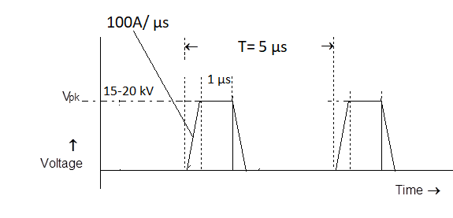
THYRATRON CONDITIONS | MIN | TYP | MAX
ANODE VOLTAGE (kV)
ANODE INVERSE VOLTAGE
PEAK FORWARD CURRENT
PEAK REVERSE CURRENT
CURRENT PULSE WIDTH
AVERAGE CURRENT
RATE OF RISE OF CURRENT
TOTAL CAPACITANCE CHARGED
PULSE REPETITIONS RATE
CURRENT PULSE SHAPE
LIFE TIME EXPECTANCY
Cooling mode:
Operating mode (continuous, burst – pulses per burst, burst prf):
Usage (Hours a Day, Hours a Week):
Other requirements:

Comments / further description of the system:

