Capacitance |  | RMS Current
Tolerance |  | Peak Current
Rated Voltage |  | Continuous Mode
Operating Voltage |  | Burst Mode
Charge Time |  | Time on
Hold Time |  | Time off
Discharge Time |  | Max Surge Current
Rate |  | Duty Cycle
Voltage Reversal |  | Fault Current
Normal |  | Temperature Range
Fault |  | Case Size
Inductance |  | Height
Design Life |  | Width
Ringing Frequency |  | Length
Normal |  | Bushing Type
Fault |  | Quantity

Name & Title: |  | Date:
Company: |  | Phone:
Address: |  | E-mail:
City/State/Zip: |  | Final Application:
Custom Capacitor Design Questionnaire

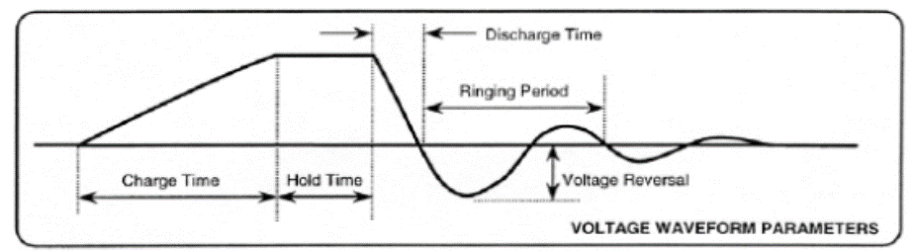
Attach Wave Forms if Available for this Application:

Comments / further description of the system:

