Name & Title: |  | Date:
Company: |  | Phone:
Address: |  | E-mail:
City/State/Zip: |  | Final Application:
Capacitor Charger Questionnaire

Output Voltage |  | Communication | Ethernet / RS232 / Optical Links / Analog Signals
Output Current |  | Working frequency
Output Power (kJ/s) |  | Repetition Rate
Output Polarity |  | Charge Time
Input Voltage |  | Hold Time
If AC: Input phases (1 or 3) |  | Discharge time
Current Regulation | Yes / No | Capacitor Value

Please include charging profile information if available:
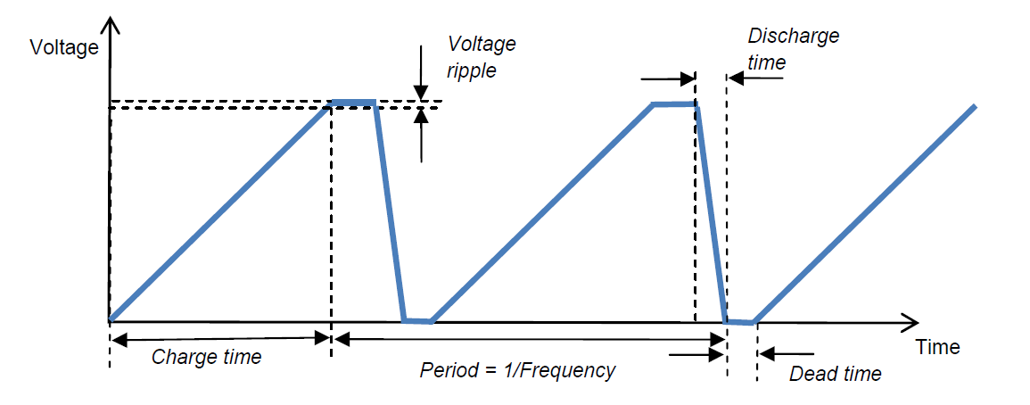

Comments / further description of the system:

